**Behavior Escalation Worksheet**

|  |  |  |  |  |  |
| --- | --- | --- | --- | --- | --- |
| **Student** |  | **Behavior Specialist** |  | **Date** |  |

**ESCALATION CYCLE**

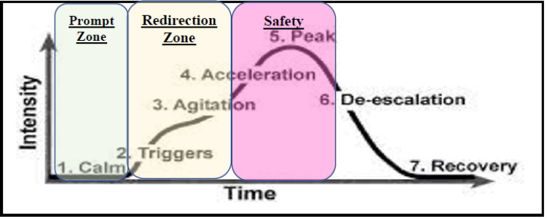

|  |  |  |  |  |  |  |  |
| --- | --- | --- | --- | --- | --- | --- | --- |
| **STEP 1: Describe the student's behaviors as they progress through each Escalation Stage (Focus on Calm to Peak)** | | | | | | | |
| **Phase** | **1: Calm** | **2: Triggers** | **3: Agitation** | **4: Acceleration** | **5: Peak** | **6: De-escalation** | **7: Recovery** |
| **Student Behavior** | *<describe student behaviors at this stage>* | *<describe student behaviors at this stage>* | *<describe student behaviors at this stage>* | *<describe student behaviors at this stage>* | *<describe student behaviors at this stage>* |  |  |
| **STEP 2: Describe any Staff Responses that contribute to Provoking or further Escalating Student Behavior at each Stage** | | | | | | | |
| **Phase** | **1: Calm** | **2: Triggers** | **3: Agitation** | **4: Acceleration** | **5: Peak** | **6: De-escalation** | **7: Recovery** |
| **Escalating Staff Response** | *<describe staff behaviors/ responses that can provoke behavior at this stage>* | *<describe staff behaviors/ responses that can escalate behavior at this stage>* | *<describe staff behaviors/ responses that can escalate behavior at this stage>* | *<describe staff behaviors/ responses that can escalate behavior at this stage>* |  |  |  |
| **STEP 3: Identify Suggested Strategies to employ at each Stage of the Escalation Cycle** | | | | | | | |
| **Phase** | **1: Calm** | **2: Triggers** | **3: Agitation** | **4: Acceleration** | **5: Peak** | **6: De-escalation** | **7: Recovery** |
|  | **Recognize what he is doing well, positively reinforce** | **Calmly Redirect Student to Use the Replacement Behavior** | **Calmly Redirect Student to Use the Replacement Behavior** | **Stay with student in sight but give space, listen to his frustration or needs, limit verbal input, stay calm to support regulation** | **Maintain safety for student & peers, limit engagement, guide towards safe space or safer choice (such as book to read)** | **Give 5-30 min of calm time, calm voice, listen, offer support and time to process/problem solve** | **Offer opportunity to talk through the situation and what caused him frustration, give time to repair if conflict occurred with adult or peer** |
| *(earn points on Daily Point Card)* | *Student will earn <ID Incentive> each day if they get 80% or more points on their Daily Point Card* | *Student will earn <ID Incentive> each day if they get 80% or more points on their Daily Point Card* | *Follow Safety Plan* | *Follow Safety Plan* |
| **Prompt the Replacement Behavior** | **Reward if student Approp'ly Requests Replacement Behavior** | **Reward if student Approp'ly Requests Replacement Behavior** |  |  |  |  |
|  | *When student approp’ly requests <Replacement Behavior> quickly provide <reinforcer>* | *When student approp’ly requests <Replacement Behavior> quickly provide <reinforcer>* |  |  |  |  |
| **Implement Interventions to Prevent Problem Behavior** | **Minimize Reinforcement for Problem Behavior** | **Minimize Reinforcement for Problem Behavior** |  |  |  |  |
| *<Add Intervention - What can be done before the behavior occurs to prevent problem or support positive behavior>* |  |  |  |  |  |  |